O’ZBEKISTON RESPUBLIKASI OLIY TA’LIM,FAN VA INNOVATSIYA
VAZIRLIGI
ABU RAYXON BERUNIY NOMIDAGI URGANCH DAVLAT
UNIVERSITETI

Kompyuter injineringgi fakulteti
“Kompyuter ilmlari va dasturlash texnologiyalari” yo’nalishi 234 guruh
Komilova Farangizning
“Web texnologiya ” fanidan
4-laboratoriya mashg’uloti

Qabul qildi:________________________________________________

Urganch-2026
LABORATORIYA ISHI №4
Mavzu: PHP orqali MySQL ma’lumotlar bazasiga ulanish
1. Ishning maqsadi
- Tayyor MySQL bazaga PHP orqali ulanish
- SELECT so‘rovlarini bajarish
- INNER JOIN orqali bir nechta jadval ma’lumotlarini chiqarish
- MySQLi (procedural, OOP) va PDO usullarini taqqoslash
- Ular orasidagi farqlarni amaliy ko‘rsatish
2. Nazariy qism
PHP orqali MySQL bilan ishlashning 3 asosiy usuli mavjud:
- MySQLi (Procedural)
- MySQLi (Object-Oriented)
- PDO (PHP Data Objects)

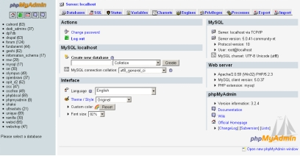
3. Amaliy baza (tayyor database)
Database: db_universitet
3 ta jadval:
fakultetlar
- id (PK)
- nomi
talabalar
- id (PK)
- ism
- kurs
- fakultet_id (FK)
fanlar
- id (PK)
- fan_nomi
- kredit
- talaba_id (FK)
4. Oddiy SELECT so‘rovi
SELECT * FROM talabalar;
5. JOIN so‘rovi
SELECT
talabalar.ism,
talabalar.kurs,
fakultetlar.nomi AS fakultet,
fanlar.fan_nomi
FROM talabalar
INNER JOIN fakultetlar ON talabalar.fakultet_id = fakultetlar.id
INNER JOIN fanlar ON talabalar.id = fanlar.talaba_id;
6. PHP orqali ulanish usullari
6.1 MySQLi – Procedural usul
<?php
$conn = mysqli_connect("localhost", "root", "", "db_universitet");
if (!$conn) {
die("Ulanish xatoligi: " . mysqli_connect_error());
}
$sql = "SELECT * FROM talabalar";
$result = mysqli_query($conn, $sql);
while ($row = mysqli_fetch_assoc($result)) {
echo $row['ism'] . " - " . $row['kurs'] . "<br>";
}
mysqli_close($conn);
?>
Xususiyatlari:
- Oddiy
- Faqat MySQL bilan ishlaydi
- Xavfsizlik PDO ga qaraganda pastroq
6.2 MySQLi – Object Oriented usul
<?php
$conn = new mysqli("localhost", "root", "", "db_universitet");
if ($conn->connect_error) {
die("Xatolik: " . $conn->connect_error);
}
$sql = "SELECT * FROM talabalar";
$result = $conn->query($sql);
while ($row = $result->fetch_assoc()) {
echo $row['ism'] . "<br>";
}
$conn->close();
?>
Xususiyatlari:
- OOP yondashuv
- Professionalroq
- Katta loyihalar uchun qulay
6.3 PDO usuli (Tavsiya etiladi)
<?php
try {
$conn = new PDO("mysql:host=localhost;dbname=db_universitet", "root", "");
$conn->setAttribute(PDO::ATTR_ERRMODE, PDO::ERRMODE_EXCEPTION);
$sql = "SELECT * FROM talabalar";
$stmt = $conn->query($sql);
while ($row = $stmt->fetch(PDO::FETCH_ASSOC)) {
echo $row['ism'] . "<br>";
}
} catch(PDOException $e) {
echo "Xatolik: " . $e->getMessage();
}
?>
Xususiyatlari:
- Turli DB lar bilan ishlaydi (MySQL, PostgreSQL, Oracle)
- Eng xavfsiz
- Prepared Statement kuchli
- try-catch bilan ishlaydi
7. PDO orqali JOIN misoli
<?php
try {
$conn = new PDO("mysql:host=localhost;dbname=db_universitet", "root", "");
$conn->setAttribute(PDO::ATTR_ERRMODE, PDO::ERRMODE_EXCEPTION);
$sql = "SELECT
talabalar.ism,
talabalar.kurs,
fakultetlar.nomi AS fakultet,
fanlar.fan_nomi
FROM talabalar
INNER JOIN fakultetlar
ON talabalar.fakultet_id = fakultetlar.id
INNER JOIN fanlar
ON talabalar.id = fanlar.talaba_id";
$stmt = $conn->query($sql);
echo "<table border='1'>";
echo "<tr><th>Ism</th><th>Kurs</th><th>Fakultet</th><th>Fan</th></tr>";
while ($row = $stmt->fetch(PDO::FETCH_ASSOC)) {
echo "<tr>
<td>{$row['ism']}</td>
<td>{$row['kurs']}</td>
<td>{$row['fakultet']}</td>
<td>{$row['fan_nomi']}</td>
</tr>";
}
echo "</table>";
} catch(PDOException $e) {
echo "Xatolik: " . $e->getMessage();
}
?>
8. Usullarni taqqoslash
Xususiyat | MySQLi Procedural | MySQLi OOP | PDO
DB turi | Faqat MySQL | Faqat MySQL | Ko‘p DB
Xavfsizlik | O‘rtacha | Yaxshi | Eng yaxshi
try-catch | Yo‘q | Yo‘q | Bor
Prepared | Bor | Bor | Juda kuchli
Professional | O‘rtacha | Yaxshi | Eng yaxshi

9. Natija
Laboratoriya ishida:
- Tayyor MySQL bazaga ulanish amalga oshirildi
- SELECT so‘rovi bajarildi
- INNER JOIN ishlatildi
- 3 xil PHP usuli taqqoslandi
- PDO eng tavsiya etiladigan usul ekanligi ko‘rsatildi
Topshiriqlar:

16- Elektron jurnal
Database: db_jurnal
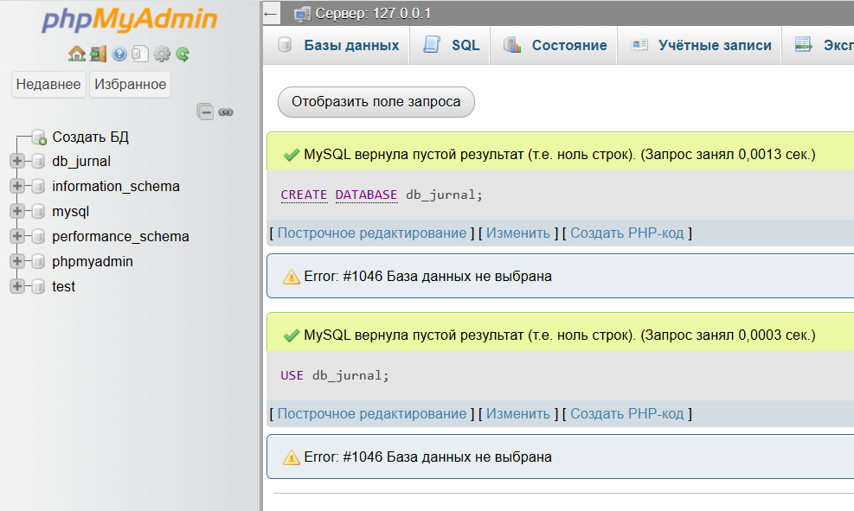

Jadvallar:
fanlar
- id
- nomi

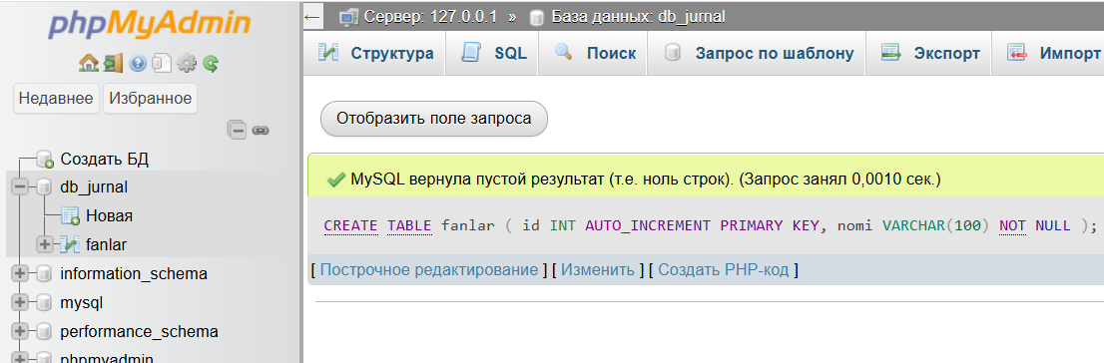
talabalar
- id
- ism
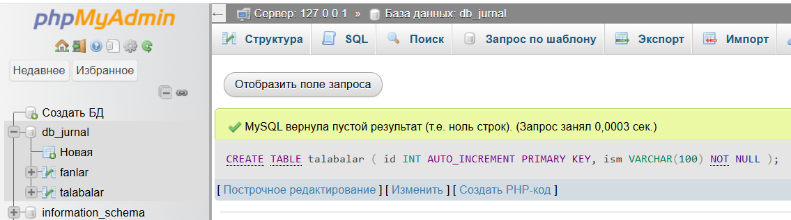
baholar
- id
- talaba_id (FK)
- fan_id (FK)
- baho
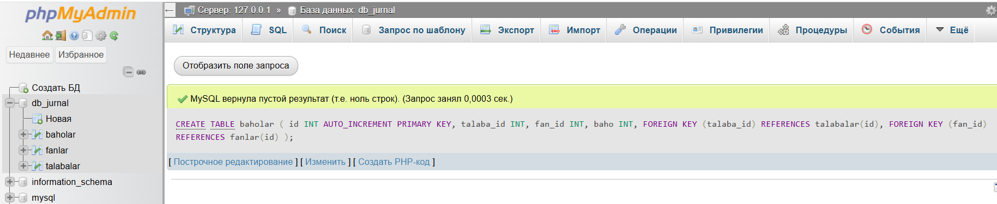
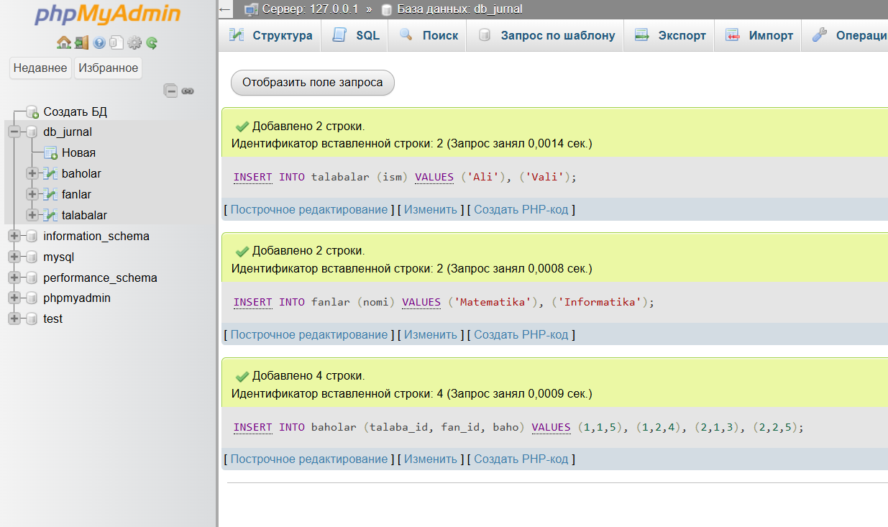

JOIN vazifa:
Talaba + Fan + Baho chiqarish.
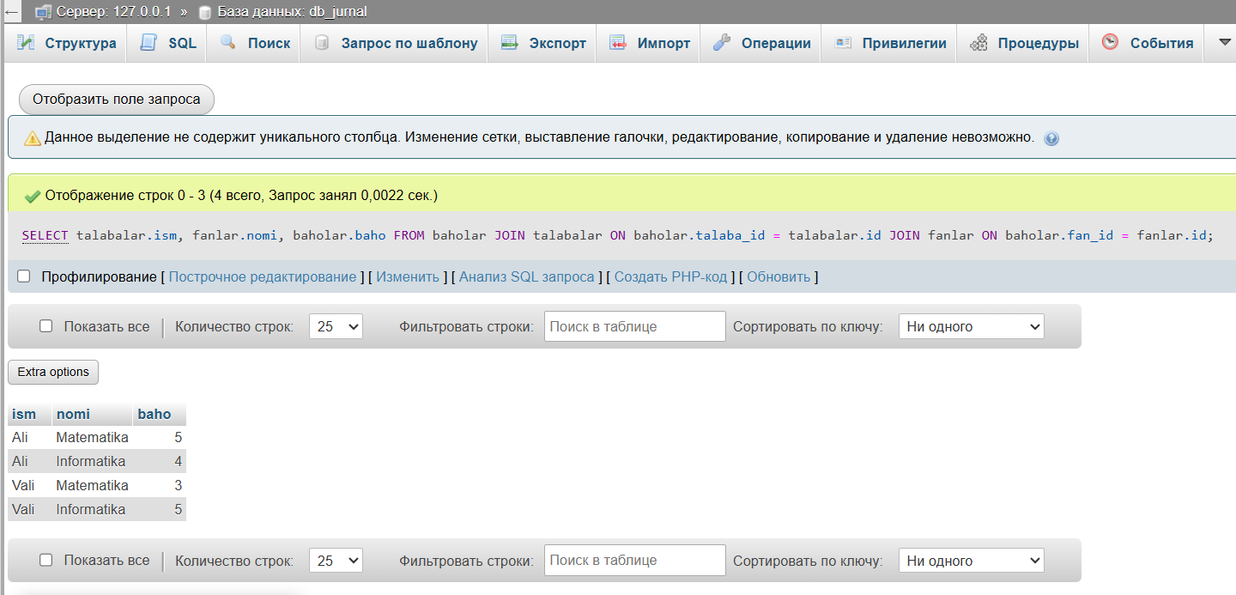

Talaba nima qiladi?
- Baholar jadvali orqali bog‘laydi
- 3 jadval JOIN
- HTML jadval chiqaradi
- <?php
- $conn = new mysqli("localhost", "root", "", "db_jurnal");
- $sql = "SELECT talabalar.ism, fanlar.nomi, baholar.baho
- FROM baholar
- JOIN talabalar ON baholar.talaba_id = talabalar.id
- JOIN fanlar ON baholar.fan_id = fanlar.id";
- $result = $conn->query($sql);
- ?>
- <!DOCTYPE html>
- <html>
- <head>
- <meta charset="UTF-8">
- <title>Elektron Jurnal</title>
- <style>
- body { font-family: Arial; padding: 30px; }
- table { border-collapse: collapse; width: 60%; }
- th, td { border: 1px solid black; padding: 10px; text-align: center; }
- th { background: #4CAF50; color: white; }
- </style>
- </head>
- <body>
- <h2>Elektron jurnal</h2>
- <table>
- <tr>
- <th>Talaba</th>
- <th>Fan</th>
- <th>Baho</th>
- </tr>
- <?php while($row = $result->fetch_assoc()) { ?>
- <tr>
- <td><?php echo $row['ism']; ?></td>
- <td><?php echo $row['nomi']; ?></td>
- <td><?php echo $row['baho']; ?></td>
- </tr>
- <?php } ?>
- </table>
- </body>
- </html>

